Key cloud accessibility and storage considerations of Google sheet
ABSTRACT
With the ascent of the cloud, information security has changed significantly. More established information security models dependent on strengthened edge protections have offered approach to new cloud security models dependent on confirmation and approval. Not exclusively can edge guards presently don't give satisfactory security to information since, similar to dividers in the actual world, they can generally be penetrated, yet a cutting-edge association's information can presently don't be kept behind a walled garden. With these changes, it is essential to survey the top contemplations for public cloud e.g. Google Cloud.

How to Convert Excel to Google Sheets (Step-by-Step)
The conflict between Google Sheets and excel clients seethes on. These are two of the most famous accounting programs. The individuals who are open to utilizing Google sheets depend on it, while excel enthusiasts like to remain inside their windows platform. Most Excel file formats that are supported by Google Sheets include:.xls,.xlsx,.xlsm,.xlt,.ods,.csv,.tsv, and .tab.
Steps
You must first have the file in your Google Drive before you can open it in Google Sheets. To open an Excel file in Google Sheets, the first move is to save it to your Google Drive.
Follow the steps below to upload an Excel file to your Google Drive:
- By typing drive.google.com into the address bar of your browser, you can access Google Drive.
- Select New in the top left corner of the Google Drive tab, then select File Upload from the drop-down menu.
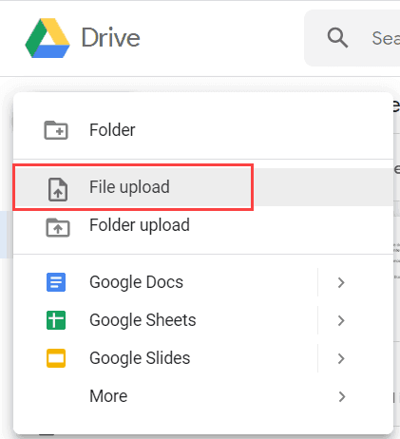
Figure 1 Google drive

- Select the Excel file you want to upload from your computer. Give it a few seconds to upload
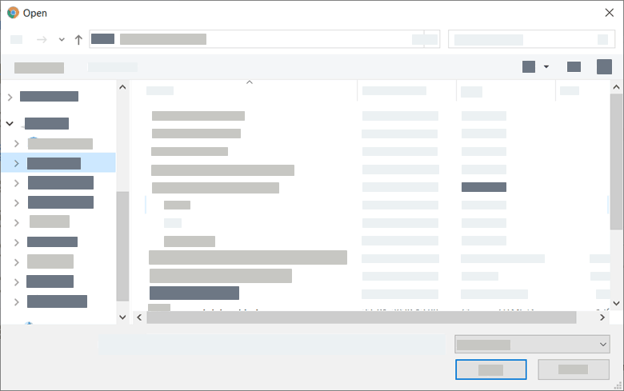

Figure 2 uploading the File via google drive
If you follow the steps above, your Excel file will be added to the drive and you will be able to access it even if you do not have Excel installed on your computer.
Simply double-click on the file to see the contents.
You can only access the file at this point; no changes can be made to it.
If you want to make changes to it, press the Open in Google Docs link at the top of the screen to open it in Google Sheets.
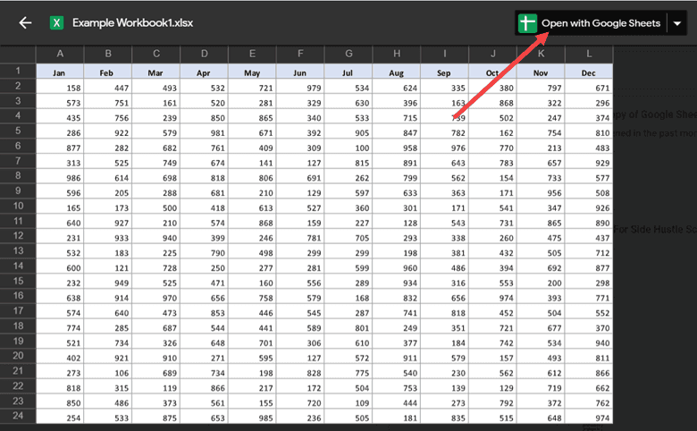
Figure 3 opening with google sheets

If you can't see it, don't worry. By right-clicking, you can still open the file in Google Sheets, then pick Open with ->Google Sheets.
Now you can edit, share and collaborate with others on data using Google Sheets.
The easiest way to preserve this file is to save all changes to the original Excel file.
You will not only want to edit your file in Google Sheets, but save it in Google Sheets format instead of Excel format.
If so, make sure your file is already open on Google sheets, pick Save as Google Sheets from the File menu.
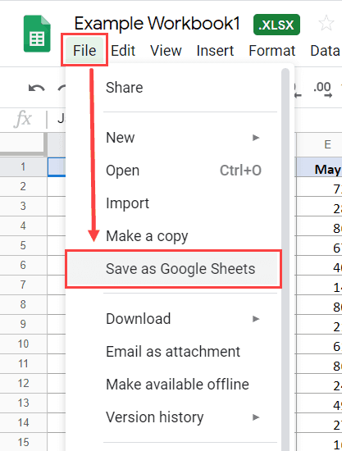
Figure 4 Save as Google Sheets
You will now have two versions of the same file, one in Excel and one in Google Sheets format.
But even though you alter this Google Sheet file, your original.xls file will stay unchanged.
How to Automatically Upload Future Excel File
You can configure your Google Drive to convert Excel file uploads to Google Sheet format automatically.
This will save you time if you also need to use Excel files in Google Sheets. You can set as follows:
- Open Drive Google.
- Click the button on the top right
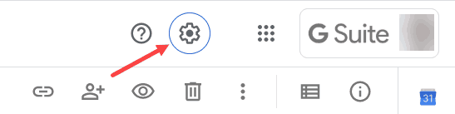
Figure 5 Gsuite
- Click Settings from the options that show up
- In the Settings box, you will see an option that says “Convert Uploads”. Check the box that says “Convert uploaded files to Google Docs editor format”.
- Click Done.

Conclusion
Though installing Microsoft Excel costs few bucks, Google Sheets are cost-free on your standard Google browser (all you need is a free Google Account). Google sheets let you collaborate on the same sheet with others so you can work in real-time with your teammates and make adjustments simultaneously. You will actually talk with these partners and does not require apps apart from browser. As Google Sheets roll out a new feature or functionality, it's available simultaneously to everyone. You should not think about versions and backward compatibility with Google Sheets. When you're working on a Google Sheet, your files are automatically backed up to your Google Drive, so moments don't stop. Using Google Sheets, you can add code and run APIs, which brings even more flexibility and functionality to your data use.
References
International Conference on Digital Economy, In Bach, T. M. A., In Jallouli, R., In Samet, A., In Touzani, M., In Strat, V. A., & In Pocatilu, P. (2020). Digital economy: Emerging technologies and business innovation : 5th International Conference on Digital Economy, ICDEc 2020, Bucharest, Romania, June 11-13, 2020 : proceedings.
Ismaili, J., Ibrahimi, E. H. O., & SpringerLink (Online service). (2016). Mobile learning as alternative to assistive technology devices for special needs students. (Education and information technologies.)
Eman K. Elsayed, Kamal A. ElDahshan, Enas E. El-Sharawy, & Naglaa E. Ghannam. (January 01, 2019). Reverse engineering approach for improving the quality of mobile applications. Peerj Computer Science, 5.
Mejia, J., Muñoz, M., Rocha, A., Peña, A., & Pérez-Cisneros, M. (2019). Trends and Applications in Software Engineering: Proceedings of the 7th International Conference on Software Process Improvement (CIMPS 2018). Cham: Springer International Publishing.

